Employee Login: INOVA-0013 – Password: Pass@123
Manager Login: INOVA-TL-3388343 – Password: Pass@123

PersonalMy Resignation
- In Create Mode Required for Request Status in Dropdown required Now System IS default in Draft Mode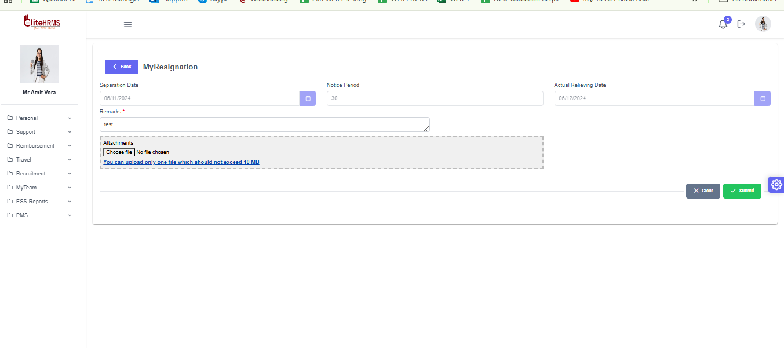
Approval Routing is not working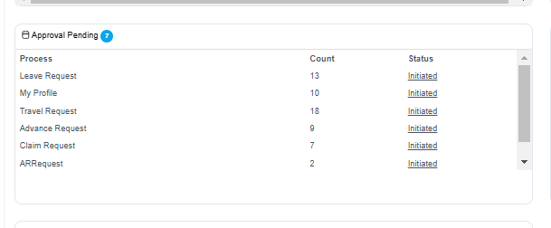

Personal Loan Entry Request
- In Create Mode Default to loaded Current Date in Loan Request Date
- Effected Payroll Month to loaded Current Month
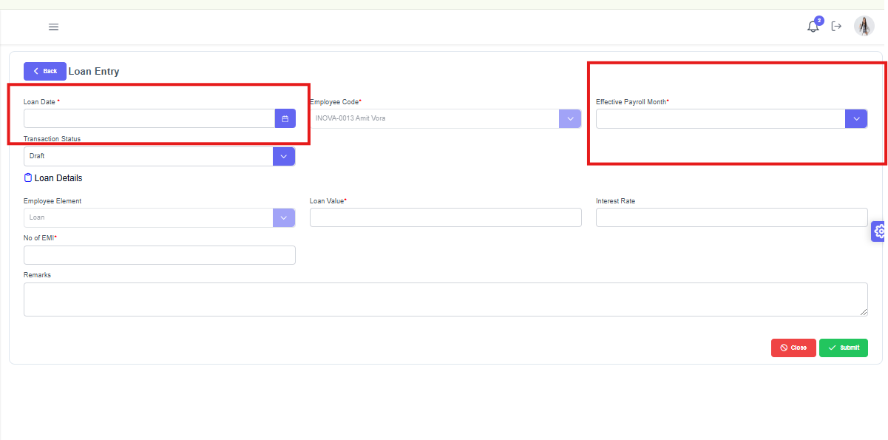

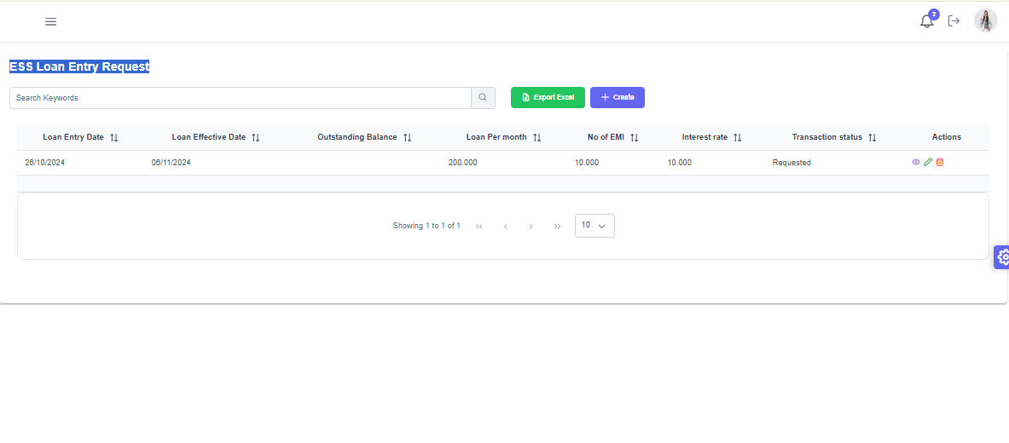3. Workflow Configuration done for Loan Entry
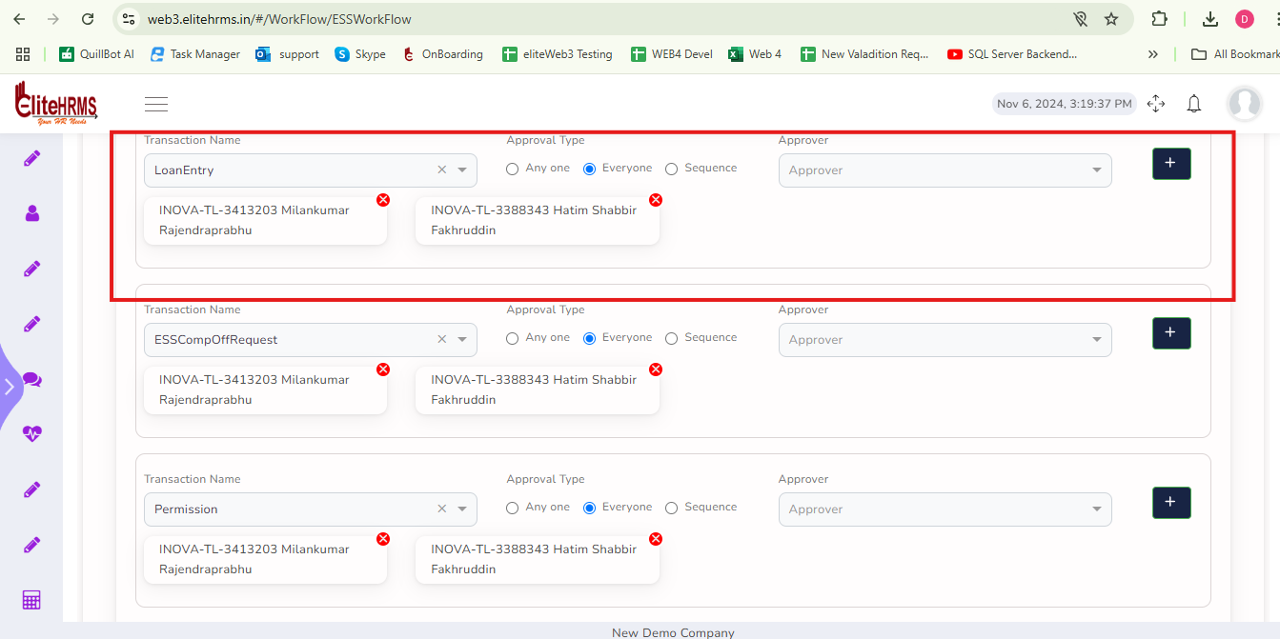
Approval Routing Is not Working
Approval Record is not Show in Team Head login - INOVA-TL-3388343
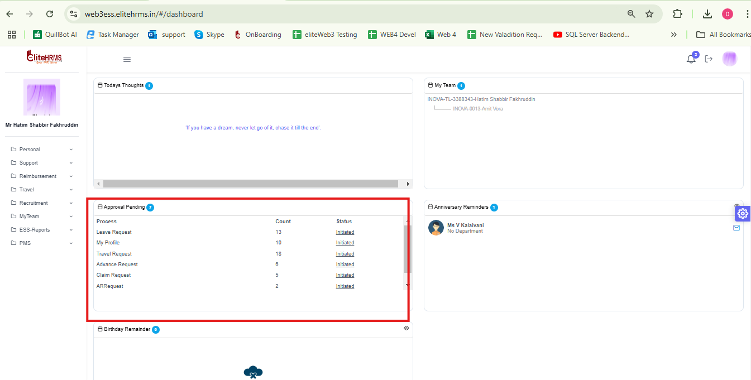

Personal ESS Comp off Request

Employee Login

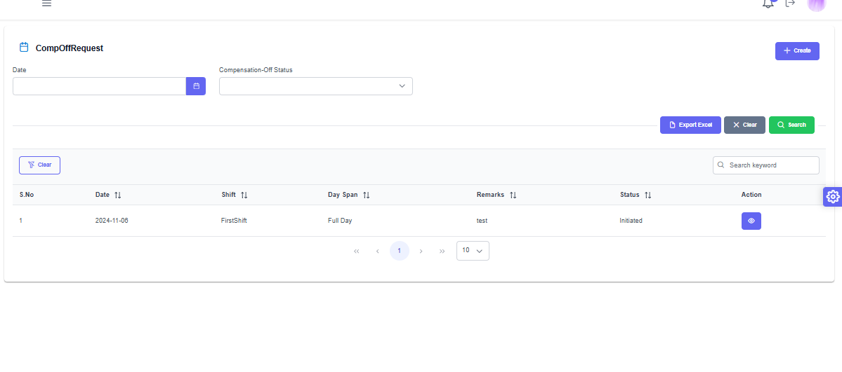

Approval Routing Is not working

Approval Records is not Show in Team Head login - INOVA-TL-3388343

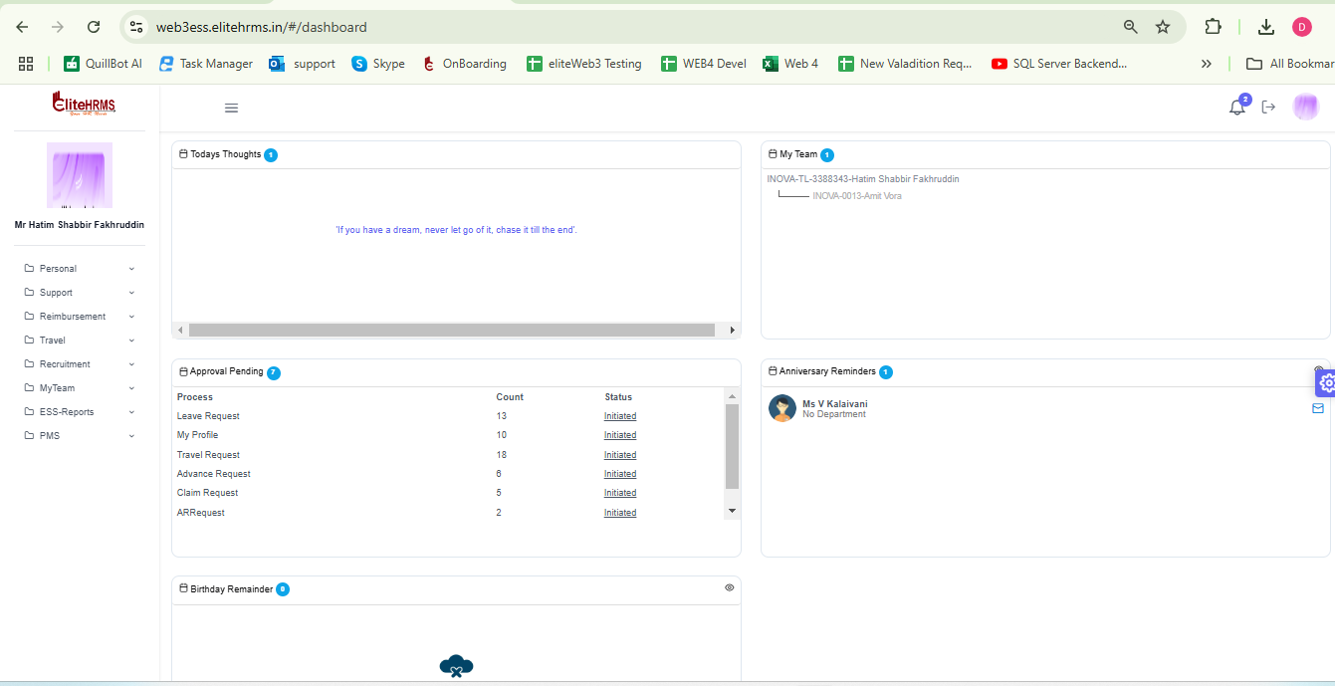

Support INFRASUPPORT REQUEST

In Search Page is not loaded below information
- Request type
- Request Status
- Action taken Status
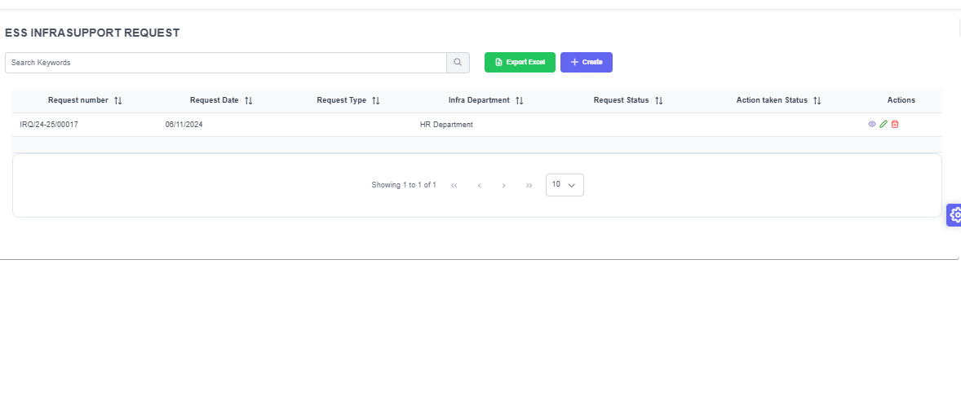

Support Policy and Document
File is how But Downloaded it show Error
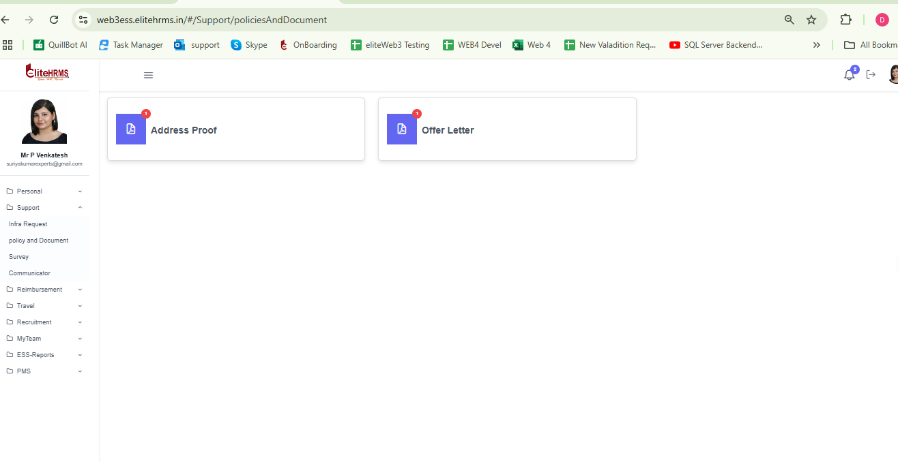

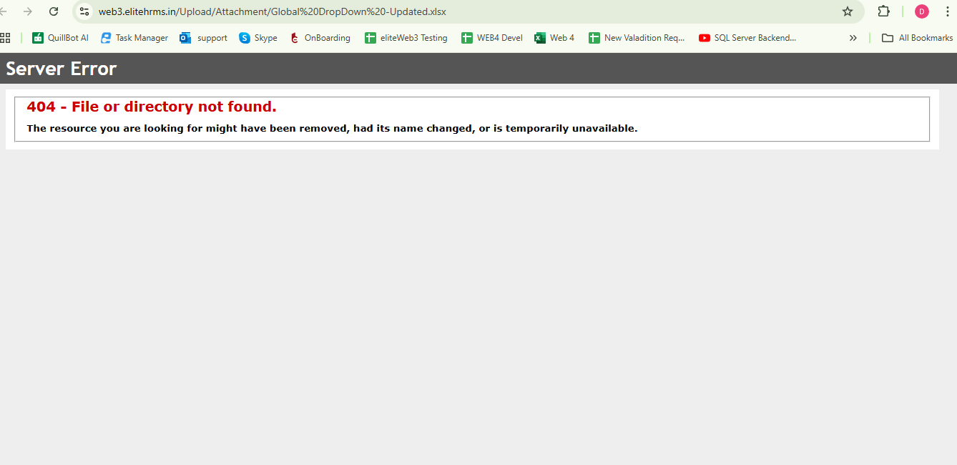

Support - Survey Save button is not working

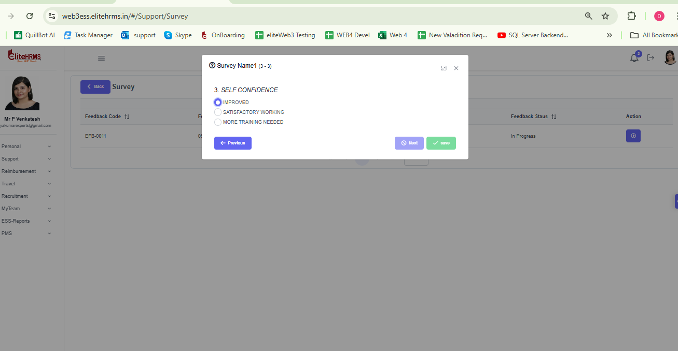

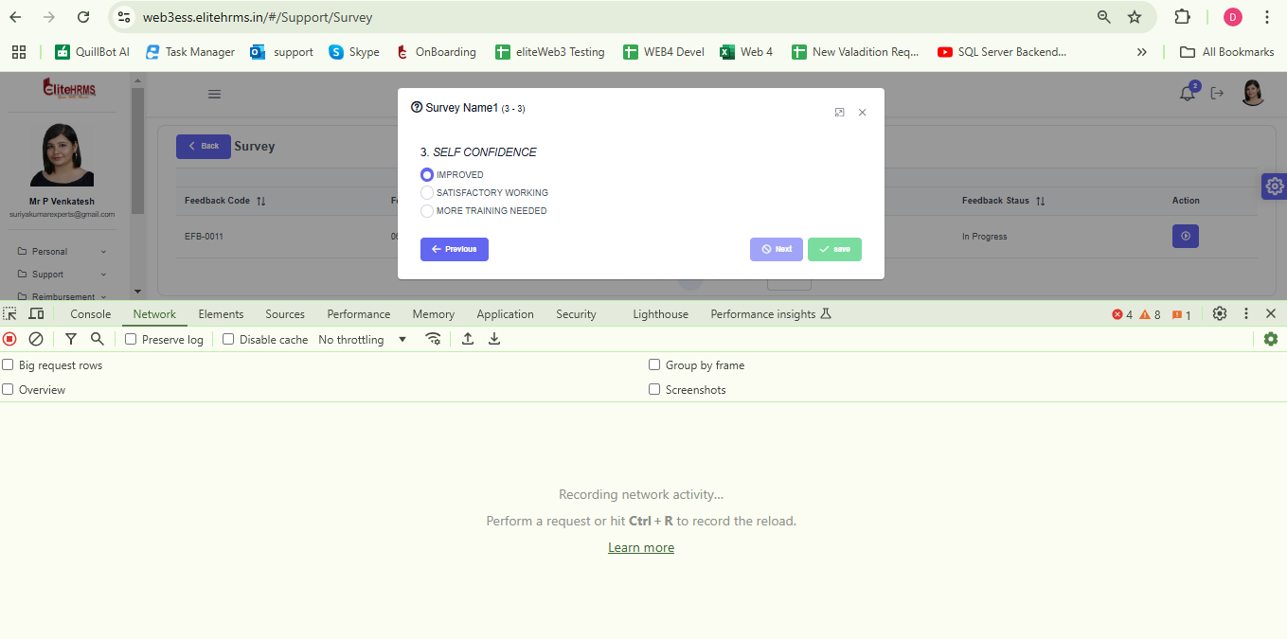

Support- Communicator

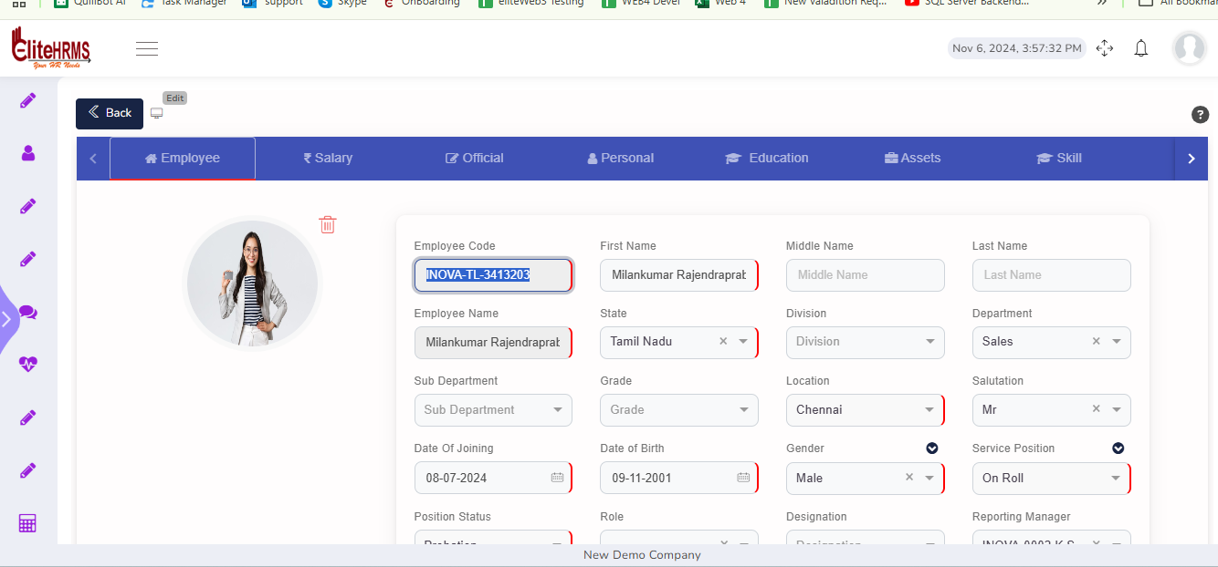
Image is not Show
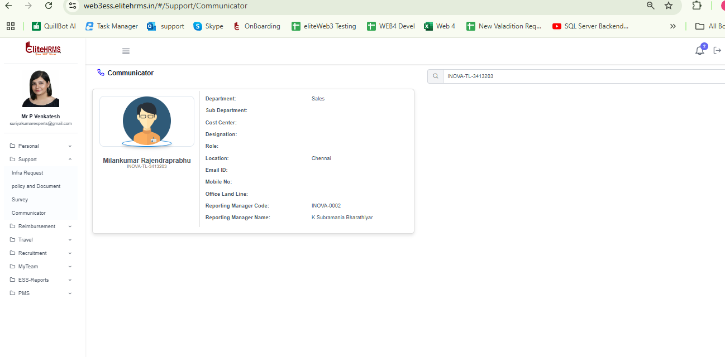

Reimbursement LTA Claim Request

ADD and Edit is not Working
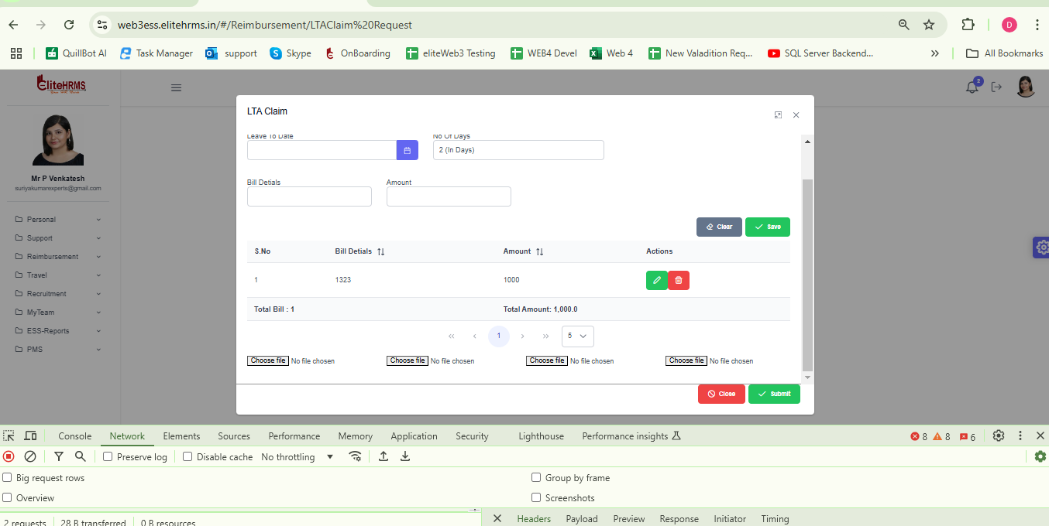

Reimbursement Travel Reimbursement Summary

ADD and Edit Is not working

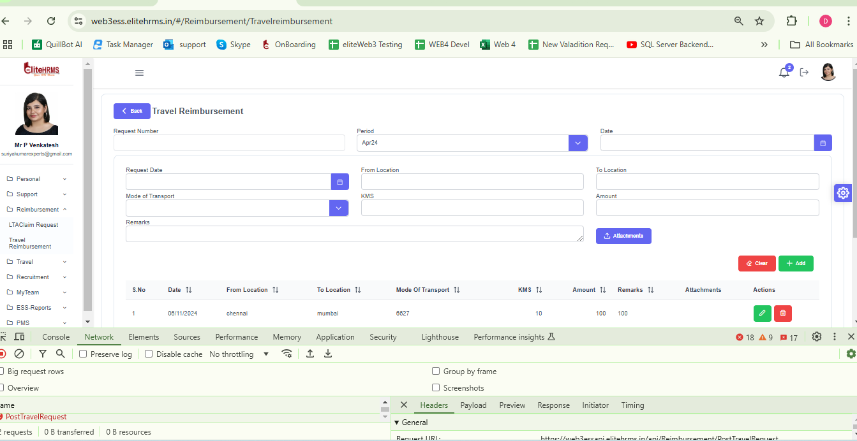

Travel- Travel Request - Working fine
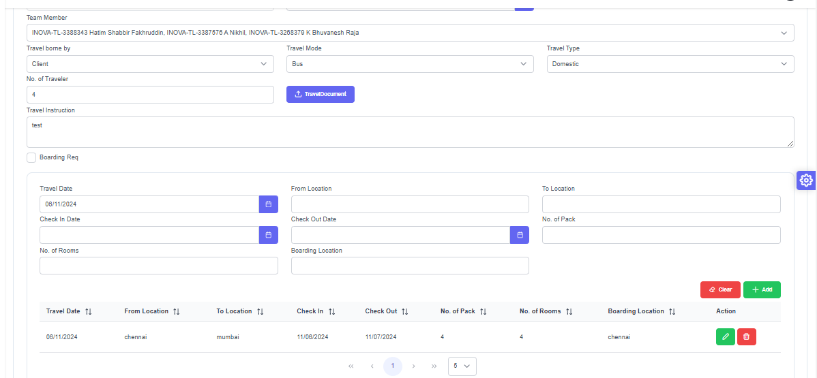

Approval routing working fine

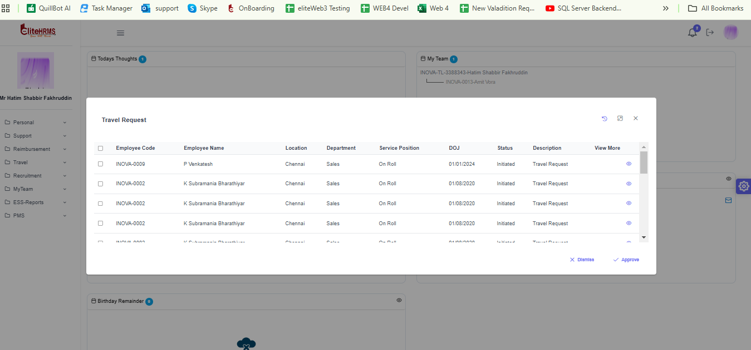

Travel Travel Advance Request

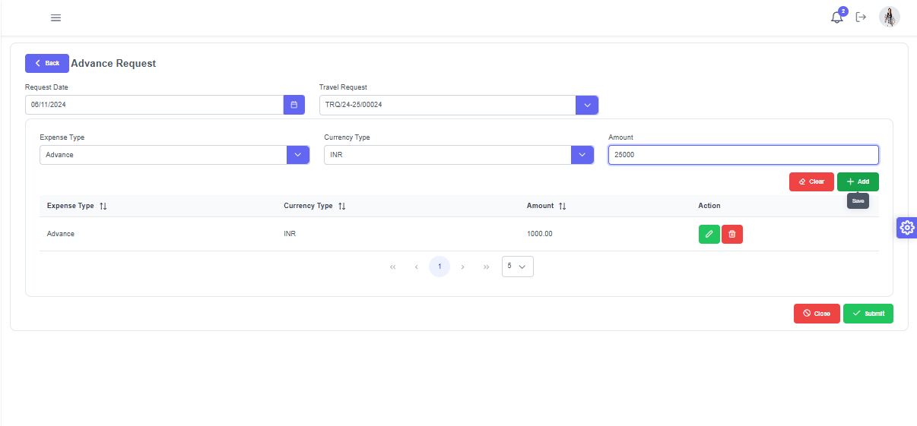

While Add button Click is not show Expense Type Currency Type in the Grid
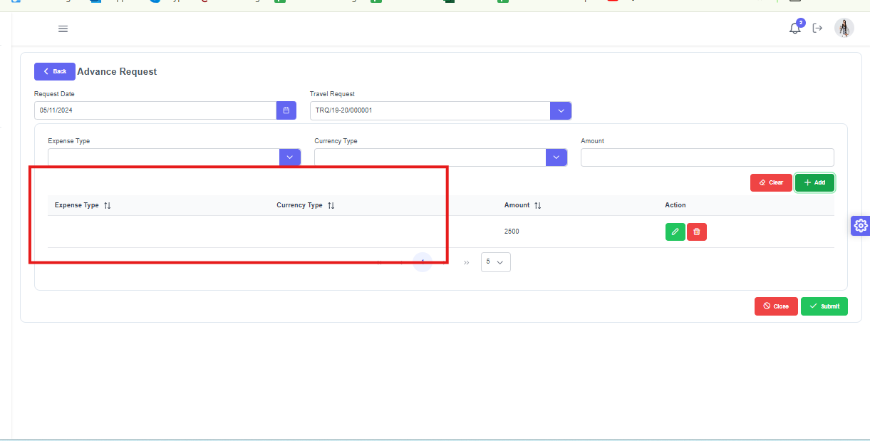

Travel Travel Claim Request

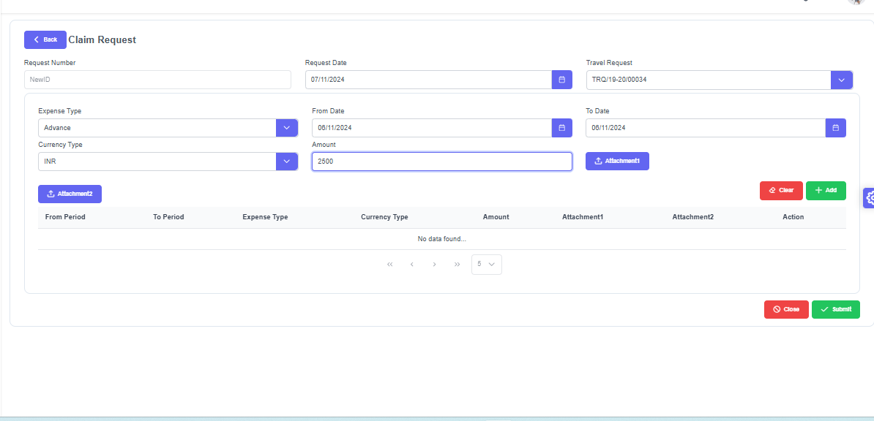

While Add Button click Grid Values is not show Expense type Currency Type
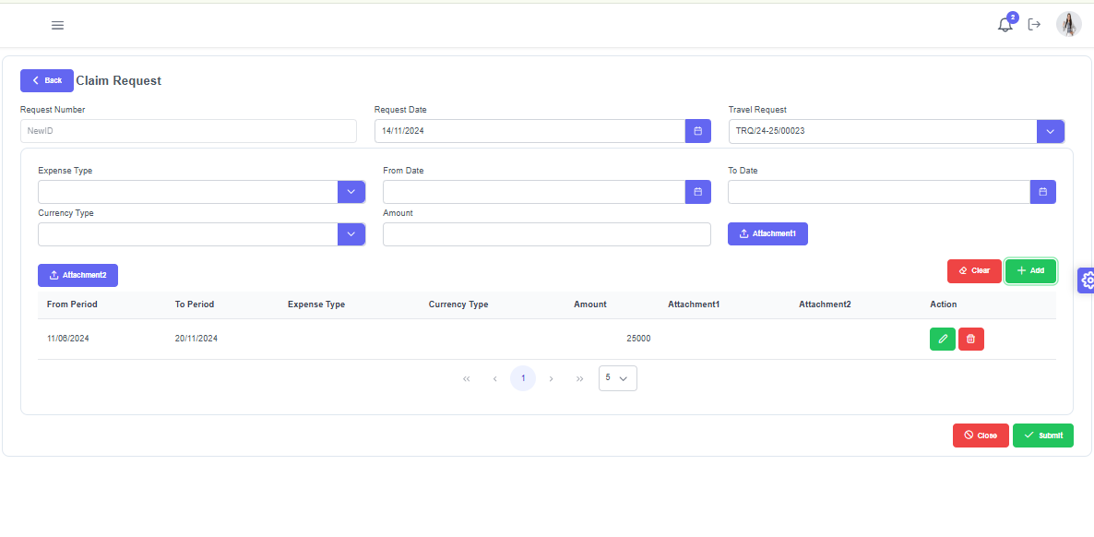

Search Page is not Show Amount, Advance Amount, and Balance Amount Currency Type 